OBJECT ORIENTED PROGRAMMING USING JAVA

NAME : P.R.DHANVIN

DEPT & SEC : CSE & B

ROLL NO : 230701071

WEEK : 5

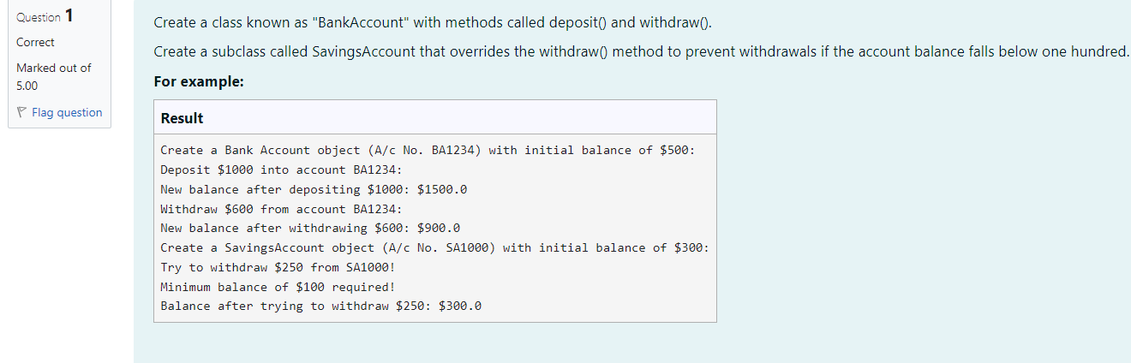

class BankAccount {  
    private String accountNumber;  
    private double balance;  
     
    public BankAccount(String accountNumber, double balance){  
        this.accountNumber=accountNumber;  
        this.balance=balance;  
    }  
     
    // Method to deposit an amount into the account  
    public void deposit(double amount) {  
        // Increase the balance by the deposit amount  
        balance+=amount;  
       
    }  
  
    public void withdraw(double amount) {  
        if (balance >= amount) {  
            balance -= amount;  
        } else {  
            System.out.println("Insufficient balance");  
        }  
    }  
  
    // Method to get the current balance  
    public double getBalance() {  
        // Return the current balance  
        return balance;  
         
    }  
}  
  
 class SavingsAccount extends BankAccount {  
    // Constructor to initialize account number and balance  
    public SavingsAccount(String accountNumber, double balance) {  
        // Call the parent class constructor  
        super(accountNumber,balance);  
         
    }  
  
    // Override the withdraw method from the parent class  
    @Override  
    public void withdraw(double amount) {  
        // Check if the withdrawal would cause the balance to drop below $100  
        if (getBalance() - amount < 100) {  
            // Print a message if the minimum balance requirement is not met  
            System.out.println("Minimum balance of $100 required!");  
        } else {  
            // Call the parent class withdraw method  
            super.withdraw(amount);  
        }  
    }  
}  
  
class prog {  
     
    public static void main(String[] args) {  
        // Print message to indicate creation of a BankAccount object  
        System.out.println("Create a Bank Account object (A/c No. BA1234) with initial balance of $500:");  
        // Create a BankAccount object (A/c No. "BA1234") with initial balance of $500  
        BankAccount BA1234 = new BankAccount("BA1234", 500);  
        // Print message to indicate deposit action  
        System.out.println("Deposit $1000 into account BA1234:");  
        // Deposit $1000 into account BA1234  
        BA1234.deposit(1000);  
         
        System.out.println("New balance after depositing $1000: $"+ BA1234.getBalance());  
         
        // Print the new balance after deposit  
         
  
        // Print message to indicate withdrawal action  
        System.out.println("Withdraw $600 from account BA1234:");  
        // Withdraw $600 from account BA1234  
        BA1234.withdraw(600);  
       
        // Print the new balance after withdrawal  
        System.out.println("New balance after withdrawing $600: $" + BA1234.getBalance());  
  
        // Print message to indicate creation of another SavingsAccount object  
        System.out.println("Create a SavingsAccount object (A/c No. SA1000) with initial balance of $300:");  
        // Create a SavingsAccount object (A/c No. "SA1000") with initial balance of $300  
        SavingsAccount SA1000 = new SavingsAccount("SA1000", 300);  
  
        // Print message to indicate withdrawal action  
        System.out.println("Try to withdraw $250 from SA1000!");  
        // Withdraw $250 from SA1000 (balance falls below $100)  
        SA1000.withdraw(250);  
        // Print the balance after attempting to withdraw $250  
        System.out.println("Balance after trying to withdraw $250: $" + SA1000.getBalance());  
    }  
}

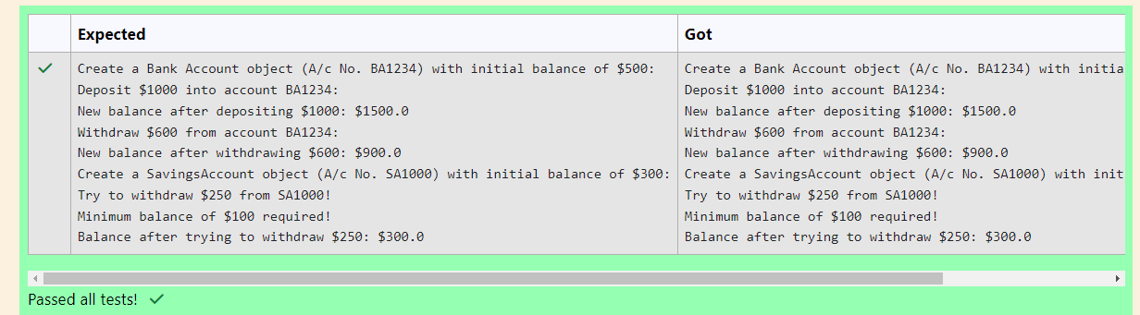

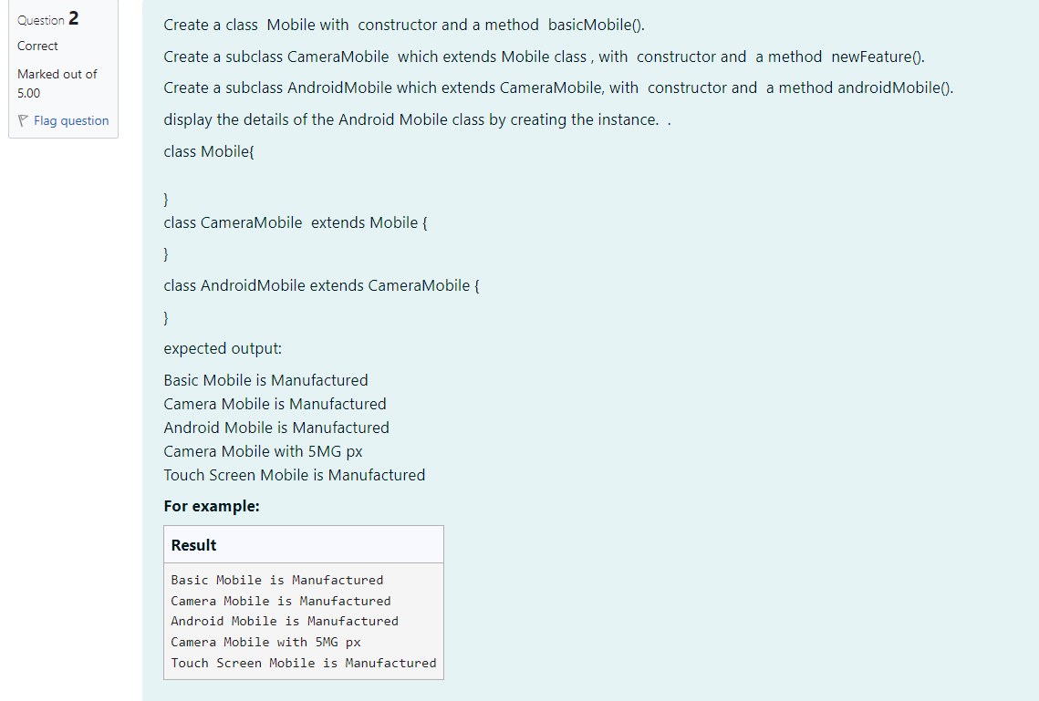

class Mobile{  
    public Mobile(){  
     
        System.out.println("Basic Mobile is Manufactured");  
    }  
}  
class CameraMobile extends Mobile{  
     
    public CameraMobile(){  
        System.out.println("Camera Mobile is Manufactured");  
    }  
    public void newFeature(){  
        System.out.println("Camera Mobile with 5MG px");  
    }  
}  
  
class AndroidMobile extends CameraMobile{  
    public AndroidMobile(){  
        System.out.println("Android Mobile is Manufactured");  
    }  
    void androidMobile(){  
        System.out.println("Touch Screen Mobile is Manufactured");  
    }  
}  
  
class prog{  
    public static void main(String[] args){  
        AndroidMobile o=new AndroidMobile();  
        o.newFeature();  
        o.androidMobile();  
    }  
}

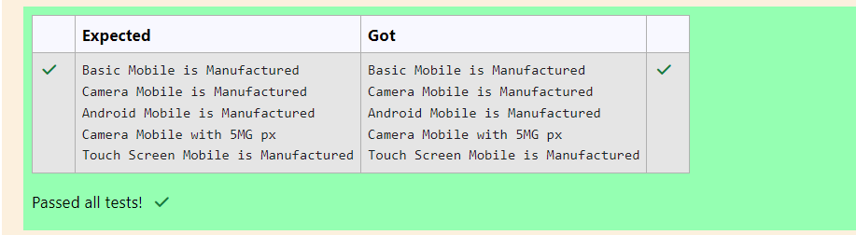

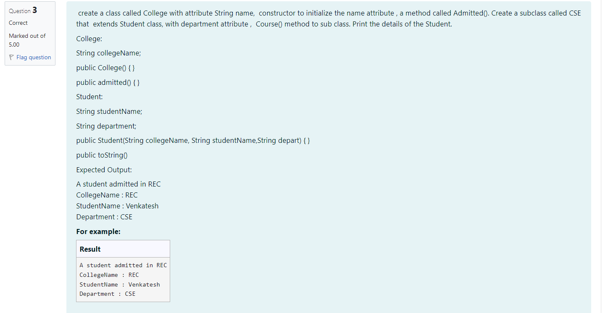

class College  
{  
protected   String collegeName;  
  
public College(String collegeNameP) {  
    // initialize the instance variables  
    collegeName= collegeNameP;  
    }  
  
public void admitted() {  
    System.out.println("A student admitted in "+collegeName);  
}  
}  
class Student extends College{  
  
String studentName;  
String depart;  
  
public Student(String collegeNameP, String studentNameP,String departP) {  
   // initialize the instance variables  
   super(collegeNameP);  
   studentName=studentNameP;  
   depart=departP;  
     
     
     
}  
  
public String toString(){  
    // return the details of the student  
    return "CollegeName : "+collegeName+"\nStudentName : "+studentName+"\nDepartment : "+depart ;  
}  
}  
class prog {  
public static void main (String[] args) {  
        Student  s1 = new Student("REC","Venkatesh","CSE");  
                                         
        s1.admitted();                             // invoke the admitted() method  
        System.out.println(s1.toString());  
}  
}

